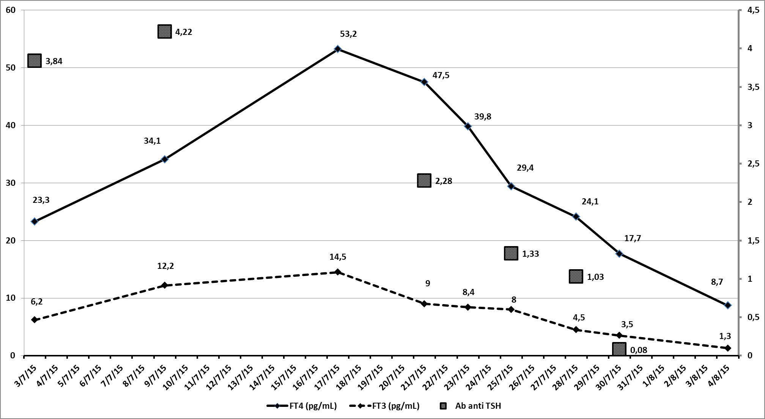
20/7 to 30/7 = PLASMAPHERESIS N° 6
31/7 Thyroidectomy
FIGURE 1.

